AIM:
WEB APPLICATION EXPERIMENT – 22

To create a simple web application using Python and host it in Microsoft

Azure to demonstrate Platform as a Service (PaaS).

PROCEDURE:
- Develop a basic Python web application using a lightweight web framework like Flask on your local system.
- Prepare the necessary deployment files such as a startup command and a requirements list for dependencies.
- Compress the application files into a .zip archive for easy deployment.
- Log in to the Azure Portal using your Microsoft account.
- Create a new App Service by selecting "Create a Resource" and choosing "App Service" from the available options.
- Configure the App Service by providing details such as resource group name, unique app name, runtime stack (Python), and region.
- Complete the creation process and wait for Azure to deploy the App Service.
- Access the newly created App Service and navigate to the Deployment Center.
- Select Local Git as the deployment method and generate the Git deployment URL.
- Push your application files to the Azure App Service using Git from your local machine.
- After successful deployment, open the App Service URL to verify that the web application is running.

OUTPUT:

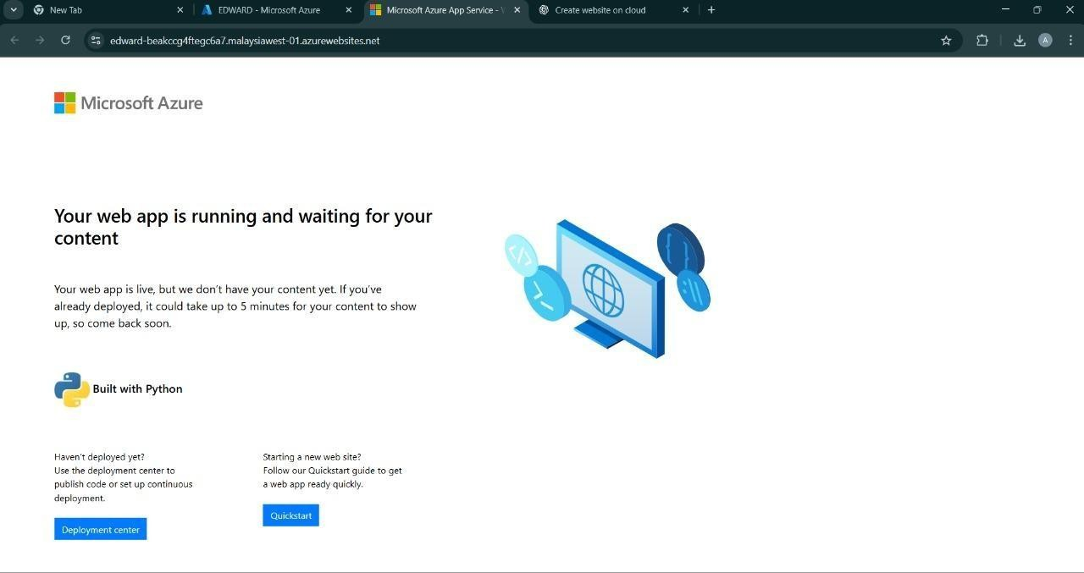

RESULT:
A Python web application was successfully created and hosted on Microsoft Azure using App Service, demonstrating the concept of Platform as a Service (PaaS).

